**INTERNET OF THINGS**

IBM NAAN MUDHALVAN PHASE 2

**PROJECT TITLE**: TRAFFIC MANAGEMENT

**END**

**KEEP GOING ON THE SAME WAY**

**IF VEHICLE OCCUPATION IS HIGH ON THE ROAD**

**CHOOSE ANOTHER WAY ON THE MAP**

**DATA ANALYSIS**

**DATA STORED IN CLOUD**

**SENSOR/CAMERA FOR DATA COLLECTION**

**INITIALIZE SYSTEM**

**START**

**DATA TRANSMISSION**

**YES NO**

**TRAFFIC CONTROLLED**

**1.SENSOR/CAMERA DATA COLLECTION:**

Traffic controlling sensors/cameras collect data on the road. It collects the vehicle capacity on the road. These sensors continuously measure the occupation of vehicles on the road.

**2. DATA TRANSMISSION:**

The collected sensor data is transmitted in real-time to the IoT platform using wireless communication protocols such as Wi-Fi, Bluetooth, or cellular networks to cloud storage.

**3. DATA STORED IN CLOUD:**

Cloud Storage is a mode of computer data storage in which digital data is stored on servers in off-site locations.  The servers are maintained by a third-party provider who is responsible for hosting, managing, and securing data stored on its infrastructure. The provider ensures that data on its servers is always accessible via public or private internet connections.

Cloud Storage enables organizations to store, access, and maintain data so that they do not need to own and operate their own data centres, moving expenses from a capital expenditure model to operational. Cloud Storage is scalable, allowing organizations to expand or reduce their data footprint depending on need.

**4. DATA ANALYSIS:**

Data analysis algorithms are applied to the stored data to assess the availability of free routes for journey. These algorithms can compare the collected data against the vehicles occupying on the road. If the occupying space is low, the system continues monitoring.

**5. ALERT GENERATION:**

If the analysis indicates poor capacity on the road, an alert is generated. This could trigger various actions such as sending notifications to users, local authorities, or facility managers.

Wifi Icon Stock Illustration - Download Image Now - Wireless Technology,  Icon, Symbol - iStock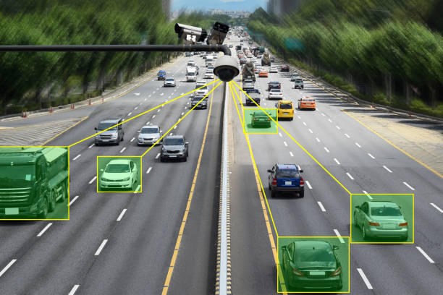 **CAMERA/SENSORS DETECT THE C0LLECTED DATAS ARE STORED**

WI-FI

**OCCUPENCY OF THE VEHICLES ON ROAD ON THE CLOUD STORAGE**

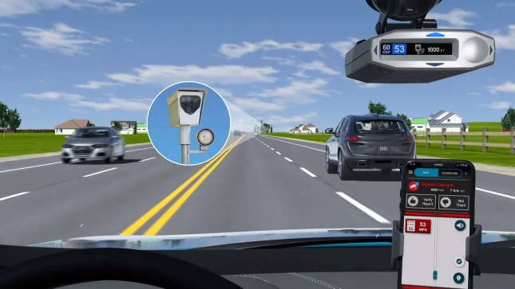

THE USER GET THE DATA AND THEY CAN EASILY GO TO THE TRAFFIC LESS ROUTES BY SEEING ONNTHE APP

TRANSFER THE ANALYSISED DATA TO ALL THE USERS

**SUMMARY:**

By using the traffic cameras/sensors we can able to find the vehicles occupying on road can be measured. Then the collected data are stored on the cloud storage. The stored data are processed. And the analysis data is passes through the users via app. They follow the instruction and they find the traffic less routes for quick and safe journey.

**Team Members**

ARASU.C (810721106001) [-arasu.c@care.ac.in](mailto:-arasu.c@care.ac.in)

HANISH.K. A (810721106007) [-hanish.k.a@care.ac.in](mailto:-hanish.k.a@care.ac.in)

SAMRUTH SRIRAM.D (810721106016) – [samruthsriram.d@care.ac.in](mailto:samruthsriram.d@care.ac.in)

SIVAGANAPATHY.R (810721106018) – [sivaganapathy.r@care.ac.in](mailto:sivaganapathy.r@care.ac.in)